Phase 4: Process Automation
Admission-Academic Journey Crm
Validation Rules:
A Salesforce rule that enforces data accuracy by preventing users from entering invalid or incomplete information.
Salesforce Path: Setup > Object manager > Select object > Validation Rule.
Procedure: Created a validation rule for Application, Student, Academic record object.
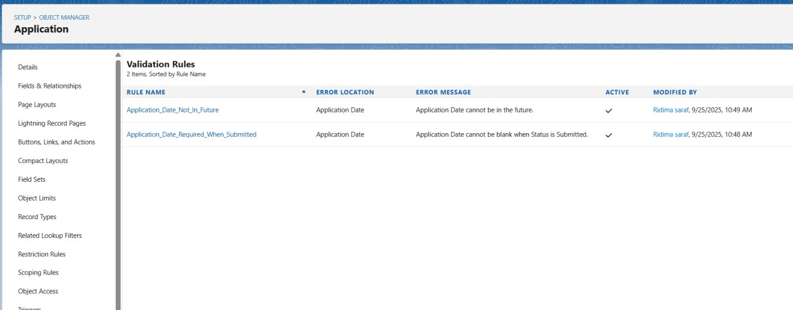

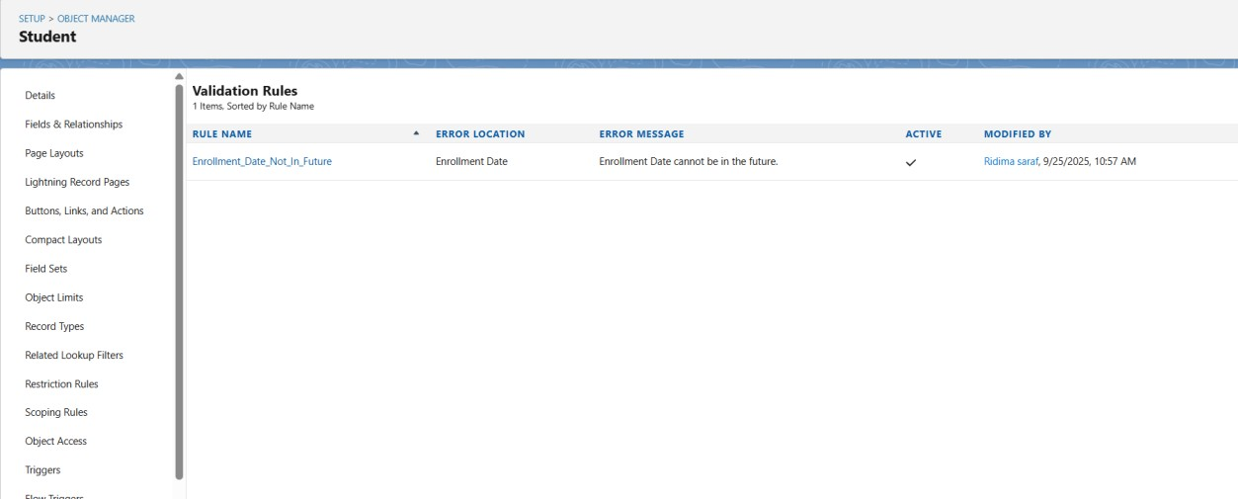

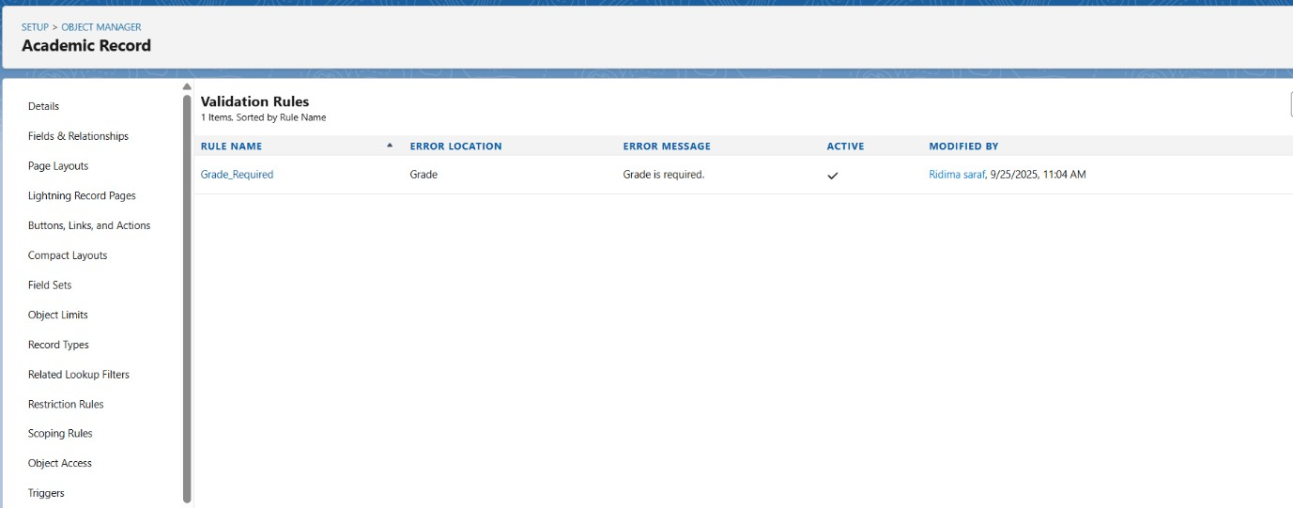

Approval Process:
The Approval Process automates the review and approval of records.
Salesforce Path: Setup > Quick find > Approval process.
Procedure: This is only created for Application object.

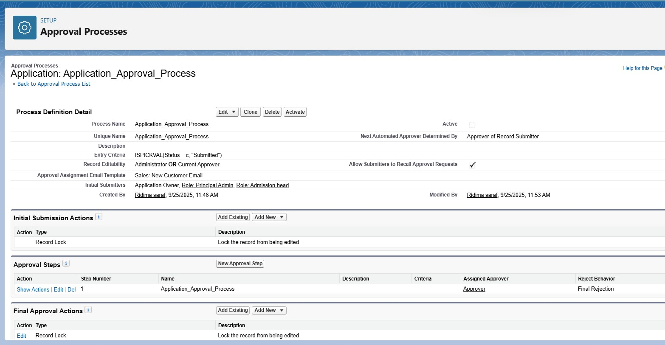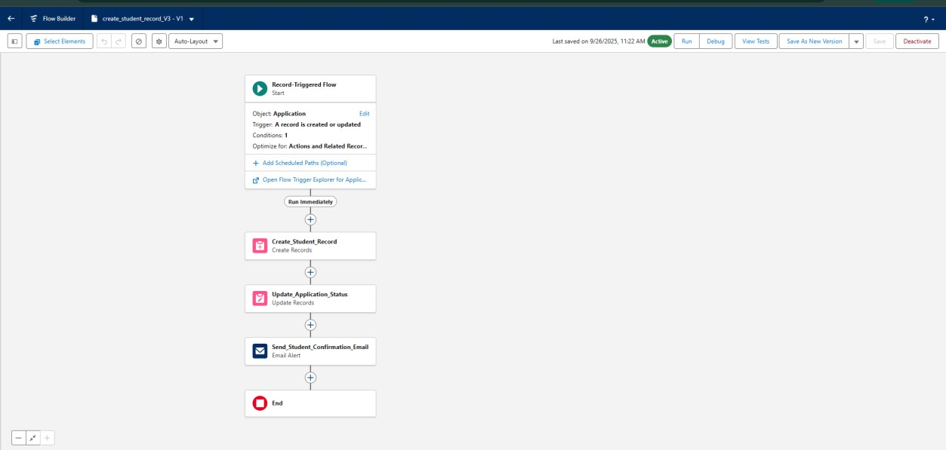

Flow Builder:
- Automate actions without manual work.
- Replace older tools like Workflow Rules and Process Builder.
Salesforce Path: Setup > Flow.
When flow is active in my project:
- Automatically create a Student record when an Application is Accepted.
- Send an email notification when Student Status = Graduated.
- Update fields automatically.

Email Template:
Email template which is created in my project are:
Salesforce Path: Setup > Email templates > New Email template.
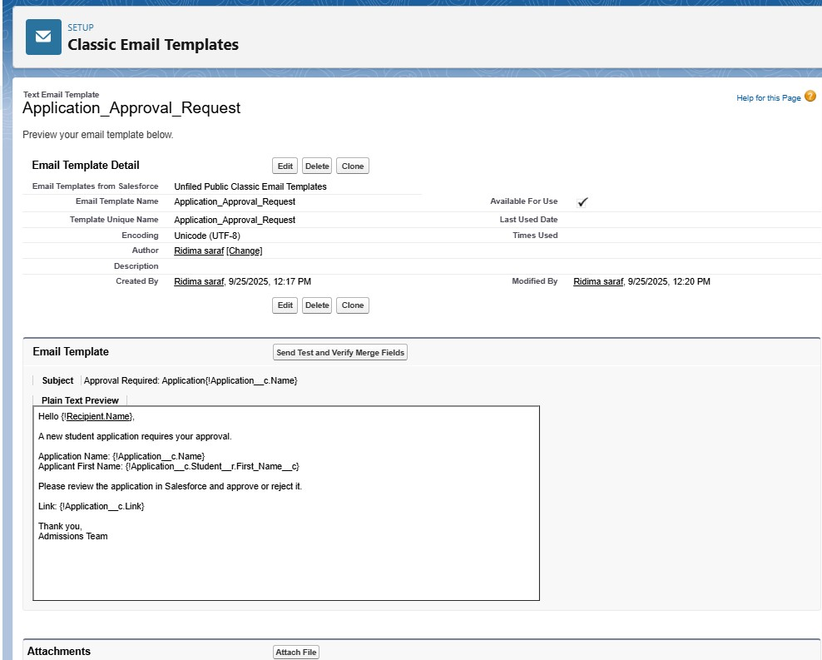

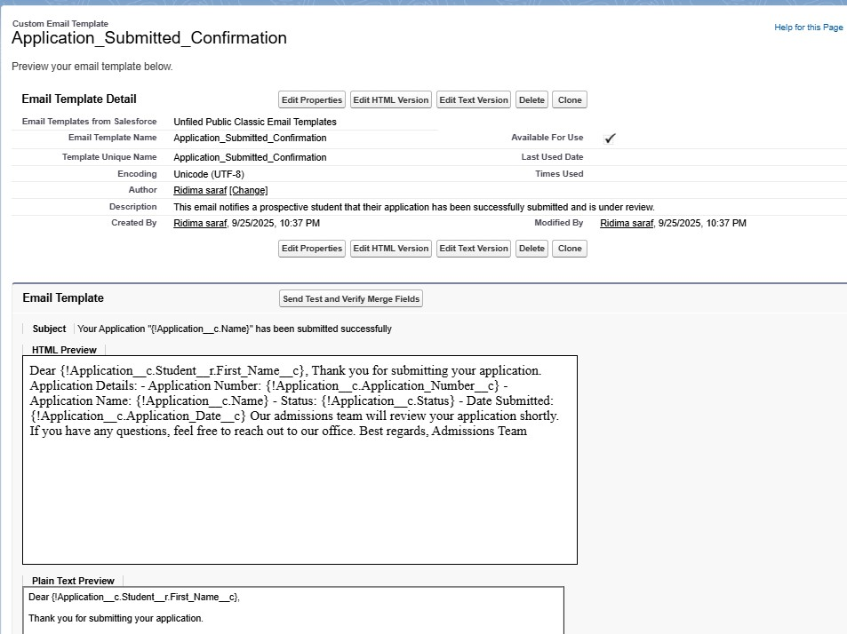

Email Alerts:
- Automate sending emails for important events in your system.
- Makes sure users and stakeholders are notified automatically.
Salesforce Path: Setup > Email Alerts > New Email alerts.
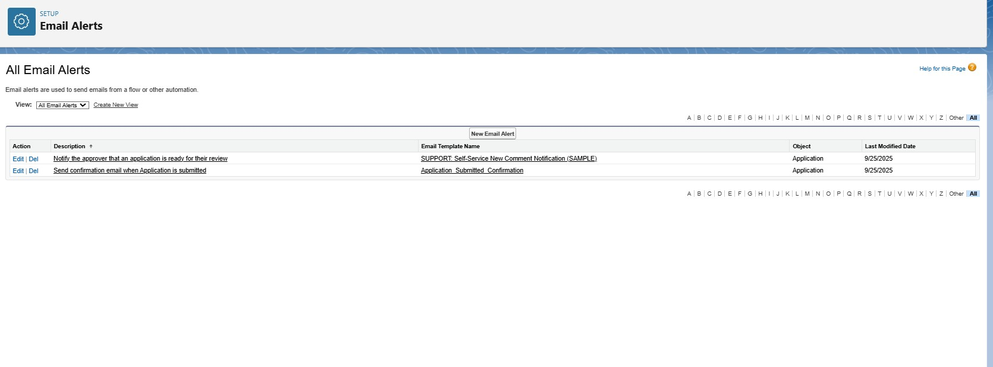
Field Updates:
- Automatically update a field on a record when certain conditions are met.
- Reduces manual data entry and ensures data consistency.
Field that I update is Update_Application_Status.

